Asian WIT Grant Detailed Information

[ General Information ]
- The research grant will provide $4000 USD. Research must commence on November 17, 2022 and conclude by November 16, 2023. (*** The maximum amount of funding is $4,000 USD. If one team is finally selected, all $4,000 USD will be provided, and if two teams are selected, it will be divided into $2,000 USD.)
- The research start date cannot be deferred for any reason.
- Applications must be submitted in full by August 25, 2022 in order to be reviewed.
- The recipient will sign a letter of agreement with AST. Payments will be issued to the recipient by AST, and the recipient will report to the ASTREG-WIT-KT project Steering Committee.

[ Research Focus ]
The Asian Society of Transplantation will fund a research that contributes to our understanding of the impact of sex and/or gender in transplantation using “Asian Society Transplant Registry-Women in transplantation-kidney transplantation (ASTREG-WIT-KT) data”. ASTREG-WIT-KT is an online registry for data collection and analysis of gender disparity across Asia-Pacific countries. Any epidemiologic, clinical studies using this data will be considered for this grant.

[ Eligibility Criteria ]
- The 1st applicant
  - NO restrictions on qualifications
  - Go to the registry platform and refer to the data list to write a proposal
- The Final Selected Applicants
  - The applicant is required to do a research about ‘Gender disparity of organ transplants’, specifically using data from the ‘ASTREG-WIT-KT platform’.
  - To use the data from the ‘ASTREG-WIT-KT platform’, the applicant must enter their country's gender disparity data into the platform. The Secretariat will create a new account for entering the data.
  - The applicant’s country’s gender disparity data should be entered into the platform within the research period (November 17, 2022 ~ November 16, 2023).
  - Only those who finally selected are given the right to view the statistical graphs of other countries to conduct the research as below.
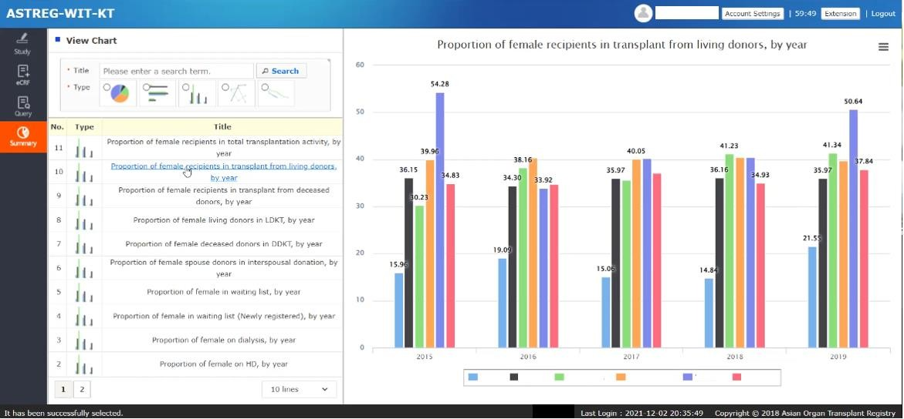
  - The successful applicants are expected to submit an abstract to the CAST (Congress of Asian Society of Transplantation) that follows their end of their research grant term.
- Platform information
- Platform website : http://ecrf.astreg.org
- ID : astreg_wit
- PW : astregwit2022!
- Steps
Website login > Click the project “ASTREG-WIT-KT”
> Click “eCRF” in the tab on the left side

- Miscellaneous
  - Sponsor/Mentor: Not required. (can be introduced by the ASTREG-WIT-KT steering committee if needed)
  - Citizenship: There is no restriction on citizenship.
  - Laboratory: there is no restriction on laboratory location/country.

[ Specific Application Requirements ]
- Completion of Asian WIT Grant Cover page (available further below), to include name, title, and institution of principle investigator, co-investigator, and/or key co- collaborator(s), institution and contact information.
- Complete proposed research plan: This document is limited to 2 pages; the page limit does not include references. The following sections must be included:
  - Aims: include the key questions posed or hypotheses to be tested
  - Introduction: provide the rationale for the research
  - Preliminary Results (if any): show preliminary results supporting the research plan
  - Research Plan: explain how the questions or hypothesis will be studied, with emphasis on experimental design over the details of the specific methods to be used. Anticipated results and potential pitfalls and alternative approaches should be briefly discussed. Specific research (and, if applicable, training) goals to be reached at the end of the grant should also be provided.
  - Significance, feasibility and outcomes of the research.
- All application materials should be sent in PDF format to the AST Secretariat (astseoul19@gmail.com) by August 25, 2022.

[ Review Process and Notification ]
- Full applications are due by August 25, 2022.
- All applicants will be notified of their application status in October, 2022.
- For the selected individuals, the term of the grant will begin November 17, 2022.

Asian WIT Grant Application Cover Sheet

Principle Investigator

- Name:
- Title:
- Institution Name & Address:
- Contact Information:
  - Email address
  - Telephone number
  - Other (Skype, Whatsapp, etc)

Co-Investigator (if relevant)

- Name:
- Title:
- Institution Name & Address:
- Contact Information:
  - Email address
  - Telephone number
  - Other (Skype, Whatsapp, etc)

Key Co-Collaborator (if relevant)

- Name:
- Title:
- Institution Name & Address:
- Contact Information:
  - Email address
  - Telephone number
  - Other (Skype, Whatsapp, etc)

Asian WIT Grant Agreement

Name:

Title:

Institution:

I confirm that:
- My research project will be conducted with appropriate ethical oversight and will abide by the Declaration of Istanbul.
- My research will commence prior to or on the start of the grant term (November 17, 2022).
- My country’s gender disparity data will be entered into the platform within the research period (November 17, 2022 ~ November 16, 2023).
- My research result will be submitted as an abstract to the CAST (Congress of Asian Society of Transplantation) that follows my end of my research grant term.

DD. MM. YYYY

Name: (Signature)

